Task 2: Test log
Description of test | Test data to be used (if required) | Expected outcome | Actual outcome | Comments and intended actions
Attempting to have the navigation bar stay at the top of the screen while scrolling | N/A | The navigation bar should stay visible at the top of the screen when the user scrolls down the page | The navigation bar does not stick to the top of the screen   | Fixed by adding the CSS:  #navbar {  position: fixed;  top: 0;  }  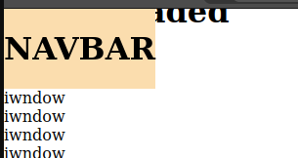
Attempting to have the navigation bar stay at the top of the screen while scrolling | N/A | The navigation bar should stay visible at the top of the screen when the user scrolls down the page, but without covering the page content when the user hasn’t scrolled yet | The navigation bar covers the page content before the user scrolls  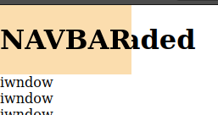 | Fixed by adding some JavaScript to calculate the height of the navigation bar, and add that as padding to a div with id  #navbar-pad  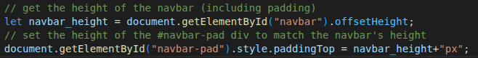  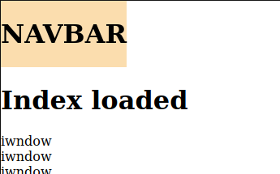
Attempting to add a logo image to the navigation bar | N/A | The navigation bar should stay visible at the top of the screen when the user scrolls down the page, but without covering the page content when the user hasn’t scrolled yet | The logo image on the navigation bar overlaps with the page content | This is due to the JavaScript for calculating the size to use for the  #navbar-pad is run before the navbar is fully rendered and styled with CSS yet.  Fixed by wrapping the existing JavaScript for #navbar-pad in an event listener so that it only runs once the page has fully rendered    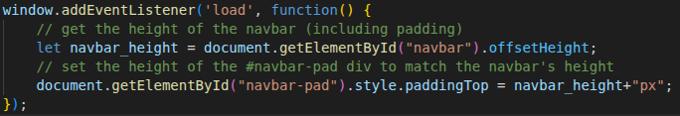
Looking back on the mock-up designs to see what to implement next | N/A | The homepage mock-up shows the navigation bar hovering on top of a banner image (without scrolling) | The prototype website I have developed does not allow for the navigation bar to hover on top of the banner image without needing to scroll | Due to the previous introduction of JavaScript code which physically offset the page content from the navigation bar, this hovering before scrolling is impossible.  Fixed by removing the previously added JavaScript code, first introduced in test log entries 2 and 3.  
Testing to see how the navigation behaves on smaller screen sizes | N/A | The navigation bar appropriately scales to the smaller screen size, home button (RZA logo) stays visible | The home button (RZA logo) disappears entirely on screens with a width of less than 1,100px   | Fixed by changing it so the logo image scales using em  .logo-img {  max-width: 4.5em;  height: auto;  margin: 0.2em;  }  
Testing to see if the navigation bar loads correctly on all pages | N/A | The navigation bar should load and be formatted appropriately on all pages | On pages without a banner image, the navigation bar covers the page content before the user scrolls (see test log entry 2) | This was caused by (in test log entry 4) the removal of the navbar padding JavaScript code that was introduced in test log entries 2 and 3. This has been fixed by reintroducing similar JavaScript, with it only running if <div id="navbar-pad"></div>  is present in the page content  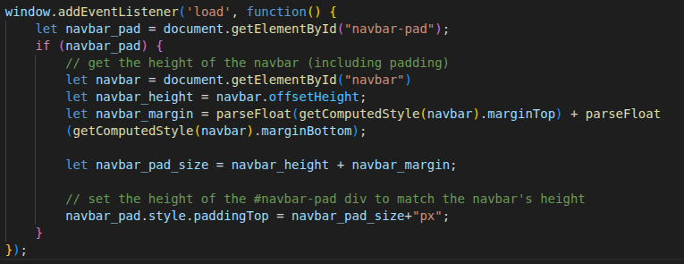  
Attempting to format a short description on the homepage | N/A | The short description should wrap similarly to the mock-up design   | The description wasn’t having the max-width CSS applied | The issue was caused by accessing the wrong variable when dynamically loading CSS.  The code was originally accessing $page_title  when it was supposed to be using  $page_name    Fixed paragraph:
Attempting to format the attractions cards in the “New attractions” section on the homepage | N/A | The images in the cards should stack next to each other to fit more on screen | The cards and images inside them do not stack next to each other  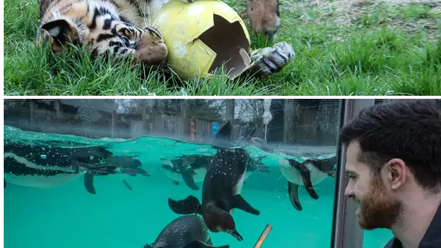 | This was caused by not including the attractions.css file in the homepage.  Fixed by adding a line to header.php that includes attractions.css on the homepage  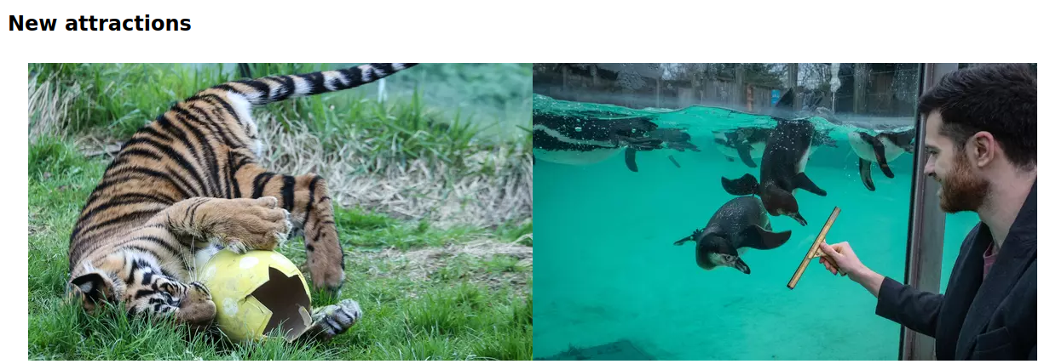  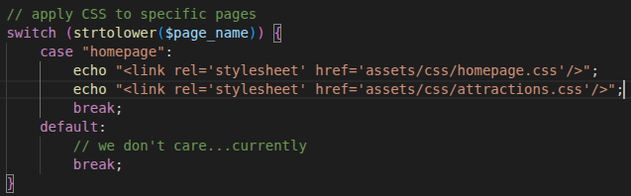
Attempting to view the newly created policies page | N/A | The policy page loads correctly | The policy page fails to load correctly and presents the user with warnings  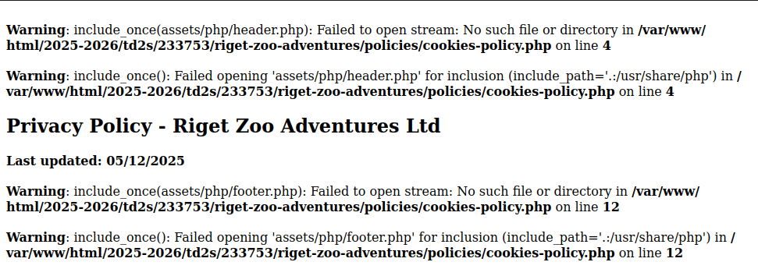 | This is caused by policies/cookies-policy.php attempting too look in policies/assets/php for header.php and footer.php, when they are actually in assets/php. This was fixed by switching to a system where a single policies.php at root file will act as a hub for and dynamically load the policies from policies/{policy_name}.html  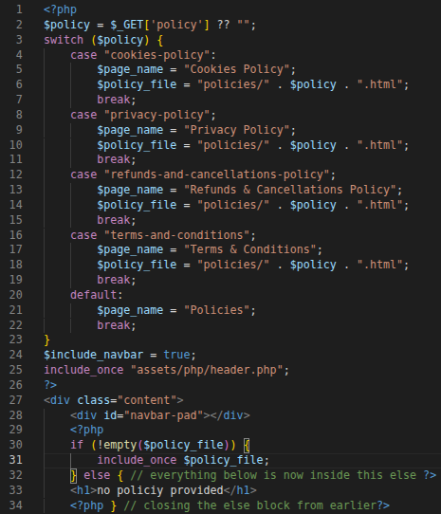
Testing to see if the website loads properly on devices not running Linux | N/A | The website loads properly and all text is readable | The website loads correctly but the font is unreadable | Fixed by updating the global font style to the one used during testing, as that was the intended look of the solution (screenshot on next page)  font-family: 'Arial Narrow Bold', sans-serif;  
Add more rows and tables as required.

